Table 1 – Basic Demographic characteristics of all patients:

|  |  |  |  |  |  |  |  |
| --- | --- | --- | --- | --- | --- | --- | --- |
|  | ***All patients*** | ***Age 66-69*** | ***Age 70-74*** | ***Age 75-79*** | ***Age 80-84*** | ***Age >=85*** | ***p Value*** |
| Number of men, (%) | 21,512 (100%) | 8,492 (39.5%) | 7,497 (34.8%) | 3,722 (17.3%) | 1,336 (6.2%) | 465 (2.2%) | - |
| Time-period, n (%)  1994-2000  2001-2007  2008-2014 | 12,131 (56.4%)  6,634 (30.8%)  2,747 (12.8%) | 4,281 (50.4%)  2,777 (32.7%)  1,434 (16.9%) | 4,317 (57.6%)  2,316 (30.9%)  864 (11.5%) | 2,360 (63.4%)  1,037 (27.9%)  325 (8.7%) | 863 (64.6%)  392 (29.3%)  81 (6.1%) | 310 (66.7%)  112 (24.1%)  43 (9.2%) | <0.001 |
| Mean Rurality index (SD) | 11.63 (17.43) | 11.66 (17.38) | 11.78 (17.72) | 11.66 (17.34) | 11.05 (16.81) | 10.06 (16.09) | 0.216 |
| Income quintile, n (%)  1  2  3  4  5  Not available | 3,439 (16%)  4,167 (19.4%)  4,289 (19.9%)  4,356 (20.2%)  5,164 (24%)  97 (0.5%) | 1,260 (14.8%)  1,570 (18.5%)  1,655 (19.5%)  1,807 (21.3%)  2,165 (25.5%)  35 (0.4%) | 1,157 (15.4%)  1,470 (19.6%)  1,498 (20.0%)  1,500 (20.0%)  1,833 (24.4%)  39 (0.5%) | 686 (18.4%)  751 (20.2%)  759 (20.4%)  706 (19.0%)  805 (21.6%)  15 (0.4%) | 242 (18.1%)  277 (20.7%)  283 (21.2%)  260 (19.5%)  268 (20.1%)  6 (0.4%) | 94 (20.2%)  99 (21.3%)  94 (20.2%)  83 (17.8%)  93 (20.0%)  2 (0.4%) | <0.001 |
| Mean ADG score, (SD) | 18.97 (11.62) | 16.85 (10.9) | 18.66 (11.28) | 21.44 (11.97) | 24.33 (12.09) | 27.49 (12.95) | <0.001 |

Table 2 - Cox proportional hazards multivariable regression model predicting the risk of prostate cancer specific death with medications modeled as ever vs. never and cumulative 6 months usage:

|  |  |  |  |  |
| --- | --- | --- | --- | --- |
|  | **Ever vs. Never** | **P value** | **Cumulative 6 months** | **P value** |
| **Hazard Ratio (95% C.I)** | **Hazard Ratio (95% C.I)** |
| **Age category 70-74 (reference 66-69)** | 1.38 (1.14-1.68) | 0.0009 | 1.4 (1.15-1.71) | 0.0005 |
| **Age category 75-79 (reference 66-69)** | 2.41 (1.93-3.02) | <0.0001 | 2.47 (1.98-3.09) | <0.0001 |
| **Age category 80-84 (reference 66-69)** | 4.18 (3.12-5.59) | <0.0001 | 4.3 (3.22-5.74) | <0.0001 |
| **Age category 85-89 (reference 66-69)** | 6.9 (4.38-10.86) | <0.0001 | 7.09 (4.5-11.15) | <0.0001 |
| **ADG score** | 1.004 (0.997-1.01) | 0.2 | 1.005 (0.998-1.01) | 0.1 |
| **Rurality index** | 1.004 (1.001-1.008) | 0.01 | 1.004 (1.001-1.008) | 0.013 |
| **Index Year** | 0.9 (0.87-0.92) | <0.0001 | 0.91 (0.88-0.93) | <0.0001 |
| **Radiotherapy vs. no radiotherapy** | 1.86 (1.52-2.28) | <0.0001 | 1.94 (1.59-2.38) | <0.0001 |
| **Radical Prostatectomy vs. no radical prostatectomy** | 0.47 (0.31-0.72) | <0.0001 | 0.44 (0.29-0.66) | 0.0001 |
| **Primary ADT vs. no ADT** | 4.36 (3.56-5.33) | <0.0001 | 4.42 (3.61-5.41) | <0.0001 |
| **Pantoprazole** | 1.23 (0.99-1.53) | 0.056 | 0.987 (0.944-1.03) | 0.57 |
| ***All other proton pump inhibitors*** | 1.39 (1.18-1.64) | <0.0001 | 1.009 (0.977-1.02) | 0.94 |
| ***Five alpha-reductase inhibitors*** | 1.11 (0.85-1.45) | 0.42 | 0.96 (0.91-1.01) | 0.139 |
| ***Glaucoma eye drops*** | 1.05 (0.79-1.4) | 0.71 | 0.99 (0.92-1.06) | 0.827 |
| All models were also included usage of statins, alpha blockers, metformin, insulin, sulphonylurea, and thiazolidinediones  ADG = Johns Hopkins' Aggregated Diagnosis Groups; ADT = Androgen deprivation therapy; PSA = Prostate specific antigen | | | | |

Table 3 - Cox proportional hazards multivariable regression model predicting the likelihood of being treated with androgen deprivation therapy with medications modeled as ever vs. never and cumulative 6 months usage:

|  |  |  |  |  |
| --- | --- | --- | --- | --- |
|  | **Ever vs. Never** | **P value** | **Cumulative 6 months** | **P value** |
| **Hazard Ratio (95% C.I)** | **Hazard Ratio (95% C.I)** |
| **Age category 70-74 (reference 66-69)** | 1.47 (1.35-1.6) | <0.0001 | 1.47 (1.35-1.6) | <0.0001 |
| **Age category 75-79 (reference 66-69)** | 2.04 (1.85-2.26) | <0.0001 | 2.04 (1.84 - 2.2) | <0.0001 |
| **Age category 80-84 (reference 66-69)** | 2.7 (2.33-3.12) | <0.0001 | 2.71 (2.35 -3.14) | <0.0001 |
| **Age category 85-89 (reference 66-69)** | 3.449 (2.658-4.47) | <0.0001 | 3.47 (2.68-4.51) | <0.0001 |
| **ADG comorbidity score** | 1.005 (1.002-1.008) | 0.001 | 1.005 (1.002-1.008) | 0.001 |
| **Rurality index** | 1.0019 (1.000-1.0037) | 0.046 | 1.001 (1.0001-1.003) | 0.04 |
| **Index Year** | 0.963 (0.954-0.972) | <0.0001 | 0.96 (0.954-0.97) | <0.0001 |
| **Pantoprazole** | 1.15 (0.978-1.35) | 0.088 | 1.03 (1.003-1.06) | 0.031 |
| **All other proton pump inhibitors** | 0.977 (0.871-1.09) | 0.692 | 0.981 (0.959-1.003) | 0.099 |
| **Five alpha-reductase inhibitors** | 1.44 (1.25-1.67) | <0.0001 | 1.09 (1.06-1.11) | <0.0001 |
| **Glaucoma eye drops** | 0.894 (0.728-1.098) | 0.287 | 0.976 (0.91-1.04) | 0.49 |
| All models were also included usage of statins, alpha blockers, metformin, insulin, sulphonylurea, and thiazolidinediones  ADG = Johns Hopkins' Aggregated Diagnosis Groups; PSA = Prostate specific antigen | | | | |

Table 4– Cox proportional hazards multivariable regression model predicting the risk of being diagnosed with prostate cancer with medications modeled as ever vs. never and cumulative 6 months usage:

|  |  |  |  |  |  |  |
| --- | --- | --- | --- | --- | --- | --- |
|  | **Ever vs. Never** | **P value** | **Cumulative 6 months** | **P value** | **Ever vs. Never (Only patients with PSA [>2007])** | **P value** |
| **Hazard Ratio (95% C.I)** | **Hazard Ratio (95% C.I)** | **Hazard Ratio (95% C.I)** |
| **Age category 70-74 (reference 66-69)** | 1.07 (1.005-1.14) | 0.032 | 1.0728 (1.0073-1.14) | 0.028 | 1.19 (0.91-1.557) | 0.188 |
| **Age category 75-79 (reference 66-69)** | 1.04 (0.967-1.13) | 0.246 | 1.05 (0.969-1.13) | 0.22 | 0.91 (0.59-1.39) | 0.66 |
| **Age category 80-84 (reference 66-69)** | 1.222 (1.08-1.38) | 0.001 | 1.22 (1.086-1.38) | 0.001 | 0.6 (0.22-1.64) | 0.32 |
| **Age category 85-89 (reference 66-69)** | 1.157 (0.924-1.44) | 0.2 | 1.16 (0.926-1.45) | 0.19 | 1.3 (0.36-4.68) | 0.68 |
| **ADG comorbidity score** | 0.999 (0.997-1.002) | 0.87 | 0.999 (0.997-1.002) | 0.87 | 1.008 (0.99-1.02) | 0.169 |
| **Rurality index** | 1.004 (1.003-1.006) | <0.0001 | 1.004 (1.003-1.006) | <0.0001 | 1.003 (0.996-1.011) | 0.31 |
| **Index Year** | 0.98 (0.974-0.986) | <0.0001 | 0.979 (0.973-0.985) | <0.0001 | 1.18 (1.1-1.26) | <0.0001 |
| **PSA** | - | - | - | - | 1.002 (1.001-1.004) | <0.0001 |
| **Pantoprazole** | 1.07 (0.929-1.253) | 0.314 | 1.02 (0.993-1.05) | 0.064 | 1.06 (0.631-1.79) | 0.81 |
| **All other proton pump inhibitors** | 0.95 (0.86-1.04) | 0.313 | 0.991 (0.97-1.01) | 0.41 | 1.344 (0.873-2.069) | 0.17 |
| **Five alpha-reductase inhibitors** | 0.924 (0.818-1.04) | 0.2 | 0.996 (0.976-1.017) | 0.74 | 1.16 (08-1.68) | 0.41 |
| **Glaucoma eye drops** | 0.960 (0.81-1.16) | 0.736 | 0.988 (0.93-1.05) | 0.71 | 1.76 (0.9-3.47) | 0.0984 |
| All models were also included usage of statins, alpha blockers, metformin, insulin, sulphonylurea, and thiazolidinediones  ADG = Johns Hopkins' Aggregated Diagnosis Groups; PSA = Prostate specific antigen | | | | | | |

Figure 1 –Percentage (out of entire study population) of prostate cancer diagnosis, any use of androgen deprivation therapy, and prostate cancer-specific death, stratified by age:

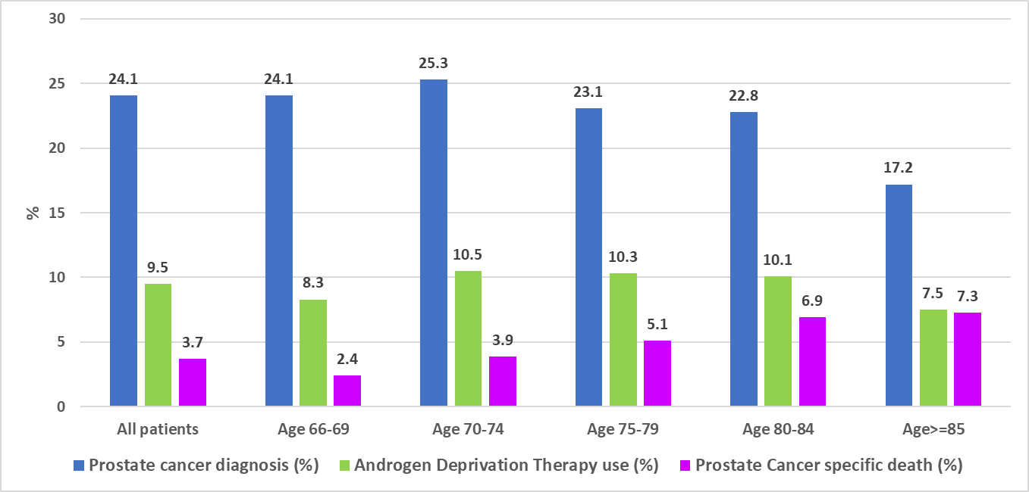

Supplemental table 1 – Source databased and Ontario Heath Insurance Plan (OHIP) database and the Canadian Classification of Diagnostic, Therapeutic, and Surgical Procedures (CCP) codes used to identify disease state and procedures:

|  |  |
| --- | --- |
| **Procedure** | **Code** |
| **Ontario Health Insurance Plan Database** | |
| Prostate biopsy | Z712, Z713, S644, E780 |
| Pelvic/abdominal ultrasound | J128, J135, J138, J149, J162, J180 |
| Radiation therapy for prostate cancer (pelvis-specific) | X336, X310, X311, X312, X313, X322 |
| Brachytherapy | S640 till 2007, afterwards X323, X324, X325 |
| Implantation of hormone pellets | G342 |
| **Canadian Institute of Health Information Discharge Abstract Database** | |
| Bilateral orchiectomy | CCP Code: 74.31; CCI Code: 1QM89 |
| Radical prostatectomy | CCP: 72.4, CCI: 1QT91 |

Supplement table 2- Negative control model - Cox proportional hazards multivariable regression model predicting the risk of being diagnosed with presbyopia with medications modeled as ever vs. never usage:

|  |  |  |
| --- | --- | --- |
|  | **Hazard Ratio (95% C.I)** | **P value** |
| **Age category 70-74 (reference 66-69)** | 0.968 (0.891-1.05) | 0.456 |
| **Age category 75-79 (reference 66-69)** | 0.991 (0.894-1.0989 | 0.87 |
| **Age category 80-84 (reference 66-69)** | 0.847 (0.717-1.0009) | 0.0512 |
| **Age category 85-89 (reference 66-69)** | 0.787 (0.585-1.059) | 0.114 |
| **ADG comorbidity score** | 1.005 (1.002-1.009) | 0.0003 |
| **Rurality index** | 0.982 (0.9801-0.985) | <0.0001 |
| **Index Year** | 0.85 (0.849-0.86667) | <0.0001 |
| **Pantoprazole** | 1.1 (0.85-1.43) | 0.448 |
| **All other proton pump inhibitors** | 1.02 (0.874-1.19) | 0.789 |
| **Five alpha-reductase inhibitors** | 1.21 (0.97-1.52) | 0.08 |
| **Glaucoma eye drops** | 1.26 (0.987-1.62) | 0.063 |
| All models were also included usage of statins, alpha blockers, metformin, insulin, sulphonylurea, and thiazolidinediones  ADG = Johns Hopkins' Aggregated Diagnosis Groups | | |

Supplemental figure 1 - Use of medications among study patients:

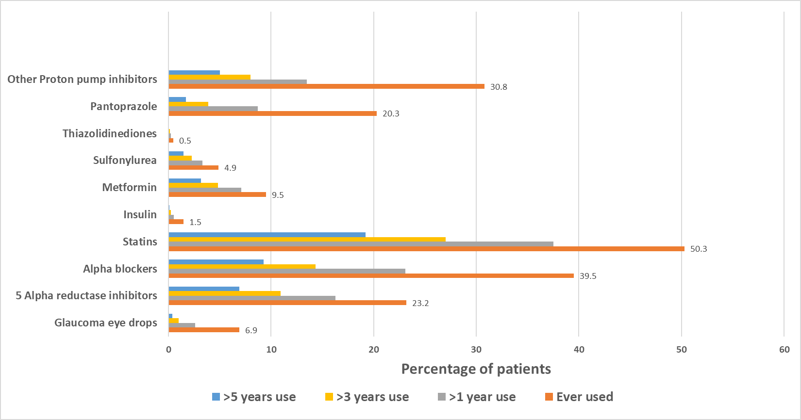

Supplemental Figure 2 – Percentage of prostate cancer treatment modalities stratified by age:

ADT = Androgen deprivation therapy; AS = Active surveillance; WW = Watchful waiting